CPAN-133 Operating System Assignment#1 Deadline:Sep 30, 2024

Wirte the Answer in your own words.

Don’t copy & paste. Read about Humber’s academic dishonesty.

Your name: Rao Krishna Humber ID: N01687444

1. (5 points) What is Operating System?

Ans It is software that works as an intermediator between computer hardware and the user. It manages the hardware resources, executes the computer applications, and provides an interface to the user.

1. (5 points) What are the main purposes of OS?

The main purposes of OS are

1. Resource Management:- Allocates hardware resources to CPU, Memory Storage, and other Programs.
2. Process Management:- Manages the execution process, and allocates necessary resources to each process.
3. File Management:- It manages the system files. It is responsible for the allocation and deallocation of storage and accessing the files and directories.
4. User Interface:- It provides an interface like GUIs to interact with hardware.
5. Security and Access Control:- It protects the system from unauthorized access and ensures that users have appropriate permission.
6. Error detection and Handling:- Handles and provides mechanisms to ensure stability and reliability
7. (5 points) What are multiuser and multitasking Systems?

Multiuser systems are the ones that allow multiple users to access the computer resources simultaneously. While a multitasking system multiple tasks to run at the same time for a single user.

1. (5 points) What is Linux and Linux Kernel?

Linux is an open-source operating system that can be used across many devices. It was developed in 1991 by Linus Torvalds. It worked on collaboration and transparency principles. Key features of Linux are:-

Open Sources:- The source code of Linux is freely available and can be used by anyone.

Versatile:- It can be optimized for each sort of hardware and different usage scenarios and therefore is appropriate for both supercomputer applications and IoT gadgets.

Security: Linux is renowned for its security features, including user permissions, and the community is very interested in managing vulnerabilities.

Stability and Performance: It is very stable, hence it can run day in and day out without the need for rebooting; hence, it is used on servers.

1. (5 points) Discuss the brief history of Unix/Linux.

Unix

Origins (1969-1971): Unix was born at AT&T's Bell Labs, where pioneers like Ken Thompson and Dennis Ritchie, alongside others, spearheaded its development. Originally designed for single-user systems, it was one of the first operating systems written in the C programming language, which made it much easier to port across different systems.

Page 1

Instructor: Tahir Minhas Humber College Page 1 of 5

Growth and Adoption (1970s): By the early 1970s, Unix was catching on in academic and research circles. Version 6, which came out in 1975, was the first official release, quickly becoming a staple in universities for teaching and research.

Commercialization (1980s): As Unix’s appeal spread, companies began creating their own variations. Major examples include BSD (Berkeley Software Distribution) and System V, each contributing essential features and setting standards that would shape Unix's future.

Standards (1980s-1990s): The proliferation of different Unix versions led to the need for standardization. POSIX (Portable Operating System Interface) emerged to ensure these various versions could work together more seamlessly.

Decline and Legacy (1990s onward): As Microsoft Windows began to dominate the market, Unix systems saw a decline in usage. Yet, the design and architecture of Unix lived on, heavily influencing the development of modern operating systems.

Linux

Creation (1991): In 1991, Linus Torvalds introduced Linux, a free, open-source alternative to Unix. The first version, Linux 0.01, debuted in September of that year.

Community Growth (1990s): The open-source ethos of Linux attracted a growing community of developers. With support from the GNU Project, which provided crucial components like the GNU C Library, the Linux kernel rapidly evolved.

Distribution Diversity (mid-1990s): The mid-1990s saw the rise of different Linux distributions, such as Debian, Red Hat, and Slackware, each offering unique features and package management systems tailored to various user needs.

Enterprise Adoption (2000s): As Linux matured, major companies, including IBM, began supporting it in enterprise environments. This newfound stability, backed by commercial support, cemented Linux’s place in the industry.

Modern Era (2010s-present): Today, Linux is everywhere—from servers and desktops to smartphones (like those running Android) and IoT devices. The Linux Foundation now plays a central role in guiding its ongoing development and fostering collaboration across the community.

1. (5 points) What is Linux distribution? What does distribution contain? Name the four distributions.

A Linux distribution, often called a "distro," is essentially a bundled version of the Linux operating system. It includes not just the Linux kernel (the core component that communicates with your computer’s hardware) but also a set of additional software, libraries, and tools that make it ready-to-use for different purposes. Each distribution is tailored to specific needs and comes with its own package management system, desktop environment, and a unique collection of default applications.

What’s Inside a Linux Distribution:

* Linux Kernel: The core component that manages hardware communication and system resources.
* System Libraries: Key libraries that let applications communicate effectively with the kernel.
* Package Management System: Tools for handling software installation, updates, and removal. For example, APT is used in Debian-based distros, while RPM is the norm for Red Hat-based ones.
* Default Applications: A pre-packaged selection of tools, ranging from desktop utilities to multimedia and productivity applications.
* Configuration Files: Settings files that dictate the system’s behavior and appearance.
* Documentation: Manuals and guides designed to help users navigate and make the most of the system.

Four Popular Linux Distributions are Ubuntu, Fedora, Debian, Arch Linux

Page 2

Instructor: Tahir Minhas Humber College Page 2 of 5

1. (5 points) What is difference between the open source and close source. What are the contributions of open source?

|  |  |
| --- | --- |
| Open Source | Closed Source |
| Open source software refers to computer software whose source is open means the general public can access and use it. | Closed source software refers to the computer software in which the source code is closed means public is not given access to the source code |
| The source code of open-source software is public. | In closed source software the source code is protected. |
| Open Source Software in short also referred to as OSS. | Closed Source Software in short also referred to as CSS. |
| The price of open-source software is very low. | The price of closed-source software is high. |
| There are not so many restrictions on users based on usability and modification of software. | There are not so many restrictions on users based on usability and modification of software. |
| Programmers freely provide improvement for recognition if their improvement is accepted. | Programmers are hired by the software firm/organization to improve the software. |
| If the program is popular then a very large number of programmers may work on the project. | There is a limitation on the number of programmers/teams who will work on the project. |
| In open-source software, no one is responsible for the software. | In closed-source software, the vendor is responsible if anything happens to the software. |
| Examples are Firefox, OpenOffice, Gimp | Examples are Skype, Google earth, Adobe Flash. |

1. ( points) Issue the following commands
   1. (2 points) Show your working directory.

wd command will be used to see the working directory.

* 1. (2 points) Create a Folder under your home directory and name it *CPAN133Assignments*.

mkdir CPAN133Assignments will create this directory.

* 1. (2 points) Create a subfolder in *CPAN133Assignments* and name it *Assignment1*.
  2. (2 points) Create a file under *Assignment1* and name it *a1file.txt*.
  3. (2 points) Write your first name and your last name in the above file. (f) (2 points) What is the absolute path to *a1file.txt* ?c

1. (2 points) What is the relative path to *a1file.txt* assuming your current directory is your home directory?
2. (2 points) Display the current date and add it to a file named *date.txt*. This file should be under the Assignment1 directory.
3. (2 points) Assume you are under the directory *ITC5101Assignments*. Issue a command to display the content of the directory named *Assignment1*. Use relative path.

Page 3

Instructor: Tahir Minhas Humber College Page 3 of 5

1. (2 points) Assume that your current directory contains the files ’term-test’, ’term-test1’, ’term- test2’, ’term-test2a’, ’term-test3’, and ’term-test4’. Issue a command to delete only the files ’term- test1’ and ’term-test2’ using wildcards.

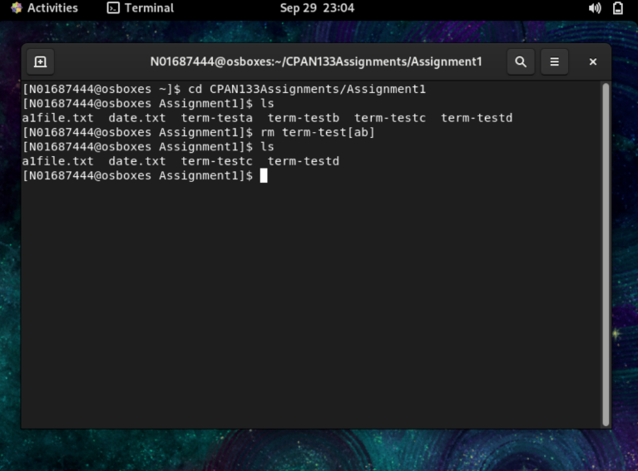

1. (5 points) Here are two inverted-tree diagrams. Issue a command to change the left diagram to the right diagram. Assume that you are in your home directory and use relative pathnames. [~] is your home directory.

Figure 1: Tree Diagram Q.No 9

Page 4

Instructor: Tahir Minhas Humber College Page 4 of 5

**Submission Guidelines**

Submit a pdf containing your answers to the questions on the submission link (Submission of Assign- ment1) under the Assignment Submission Folder on Blackboard.

Your document should contain your information: full name, student id and, section number.

Name the document as follows:

If your last name is Minhas and your name is Tahir, your assignment’s pdf file will be: MinhasTahirA1.pdf

LATE SUBMISSION will be penalized 5% per day up to 5 days

|  |  |  |  |  |  |  |  |  |  |  |
| --- | --- | --- | --- | --- | --- | --- | --- | --- | --- | --- |
| Question: | 1 | 2 | 3 | 4 | 5 | 6 | 7 | 8 | 9 | Total |
| Points: | 5 | 5 | 5 | 5 | 5 | 5 | 5 | 20 | 5 | 60 |
| Bonus Points: | 0 | 0 | 0 | 0 | 0 | 0 | 0 | 0 | 0 | 0 |
| Score: |  |  |  |  |  |  |  |  |  |  |

Page 5

Instructor: Tahir Minhas Humber College Page 5 of 5